Growing shade   
Interactive Tool

User Guide

White Bar Art

The Council’s mission is to foster  
efficient and economic growth for   
a prosperous metropolitan region

**Metropolitan Council Members**

|  |  |
| --- | --- |
| Charlie Zelle Chair Judy Johnson District 1 Reva Chamblis District 2 Christopher Ferguson District 3 Deb Barber District 4 Molly Cummings District 5 Lynnea Atlas-Ingebretson District 6 Robert Lilligren District 7 Abdirahman Muse District 8 | Raymond Zeran District 9 Peter Lindstrom District 10 Susan Vento District 11 Francisco J. Gonzalez District 12 Chai Lee District 13 Kris Fredson District 14 Phillip Sterner District 15 Wendy Wulff District 16 |

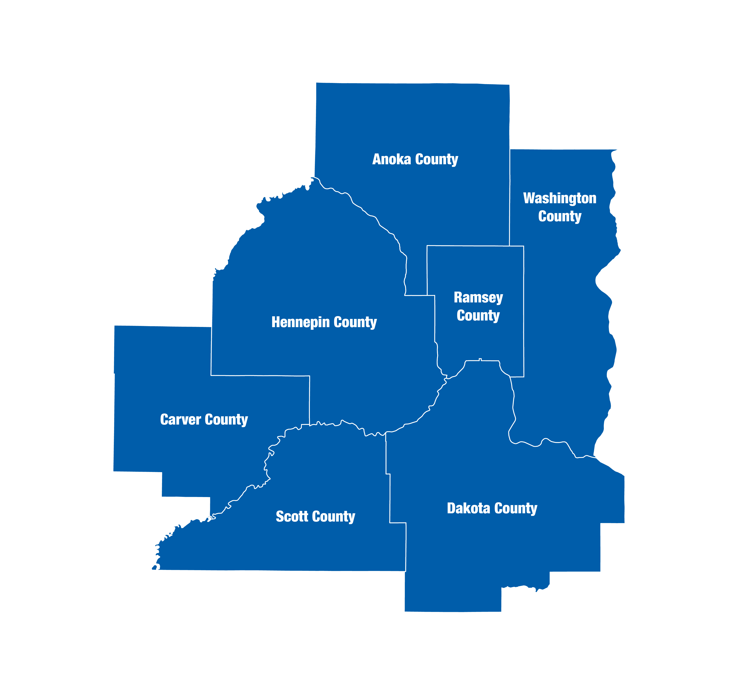  
The Metropolitan Council is the regional planning organization   
for the seven-county Twin Cities area. The Council operates the regional bus and rail system, collects and treats wastewater, coordinates regional water resources, plans and helps fund regional parks, and administers federal funds that provide housing opportunities for low- and moderate-income individuals and families. The 17-member Council board is appointed by and serves at the pleasure of the governor.

On request, this publication will be made available in alternative formats to people with disabilities. Call Metropolitan Council information at 651-602-1140 or TTY 651-291-0904.

# Introduction

## What the Growing Shade Interactive tool does

The [Growing Shade project](http://interactives.metrocouncil.org/growing-shade/) recognizes that trees provide critical ecosystem services and are important components of both natural and built environments. With a desire to create healthy places for people to live (mitigate heat islands and/or reduce home cooling costs, reduce localized flooding risk, improve mental health, etc.) and a resilient future (carbon sequestration, biodiversity, etc.), building or enhancing tree canopy cover is an actionable step.

[The interactive](http://interactives.metrocouncil.org/growing-shade/) provides stories and a mapping tool to identify areas where an enhanced tree canopy could have a disproportionately positive benefit for people and the environment. Stories provide a narrative to contextualize the importance of this work within our region. Users can customize the mapping tool to reflect specific priorities towards identifying tree planting opportunities. Resources are also provided to helping stakeholders evaluate other considerations involved with tree plantings, such as cost-benefit analysis and species considerations.

## What the Growing Shade Interactive tool cannot do

Users can create valuable, data-driven analyses through this tool. Our experience and research tells us that data cannot substitute for stakeholders engagement to understand community-specific concerns or opportunities. The on-the-ground knowledge of residents and the expertise of practitioners are valuable sources of information necessary to enhance and refine the shared understanding of this data.

# User Interface

To begin using the tool, notice the tabs on the top of the screen. Navigate to different parts of the tool by clicking on the tabs. This document goes through each tab in detail.

Click the tabs on top of the screen to navigate the tool

## “Home” tab

On the home page, scroll down to find a general overview about what this tool does, and ways in which you might find this tool useful. Scroll down to learn about trees and related issues and hear stories about local residents making a difference.

## “Mapping tool” tab

This tab allows users to create data-driven reports for communities across the Twin Cities. This page has three main components: 1) a place for users to customize the analyses, 2) a map of tree canopy prioritization and existing canopy cover, 3) a user-generated report.

An overview of the mapping tool is shown below.

Report

Customizations

Map

Toggle map layers “on” or “off”.

Use the buttons or scroll to zoom in and out. View the current tree canopy by zooming in.

Scroll down to read the report. Collapse report sections by clicking on the “minus” sign. Alternatively, download the report or raw data.

Select the geography for the report. For cities or neighborhoods, use the dropdown menu. For tracts, click an area on the map.

Click for information about using this tool.

Select a preset (or “custom”) prioritization layer. Click the question mark for help.

Get a “full screen” mode for the map.

To customize the map, select a “preset” on the left of the screen to create a tree canopy enhancement or maintenance priority layer. Selecting “custom” activates several drop down menus from which inputs can be selected. Click on a variable to turn in “on” or “off” – a “check mark” indicates that the input is being used to calculate priority scores. You can also “select all” or “deselect all” variables within a drop down menu.

More information about presets.

Select “custom” to activate more options.

A checkmark indicates this variable is being used to calculate priority scores. Click the variable to turn on or off.

Click the question mark for more information about the presets and priority scoring.

To create a report, select the geography of interest. If a “city or township” or “neighborhood” is selected, use the drop down menu to specify for which area the report should be created. If a “census tract” is selected, please click on an area within the map to create a report.

Scroll down to read the report. Alternately, download the report or the raw data. The figures in both reports are the same. The downloaded report contains more information about methodology and other considerations. The figure resolutions are higher in the downloaded report, and may be useful for making presentations or other communications.

Within the report, each section can be collapsed by clicking on the “minus” or “plus” symbol. This may be useful if you wish to compare a specific report selection across different geographies.

Zoom in on the map to view the current tree canopy (“tree” layer). We recommend taking a screenshot of the map if you will need this information offline (instructions [for mac](https://support.apple.com/en-us/HT201361) and [for windows](https://support.microsoft.com/en-us/windows/use-snipping-tool-to-capture-screenshots-00246869-1843-655f-f220-97299b865f6b)).

“Other resources” tab

Toggle map layers on or off.

This tab provides links to other tools which may be useful and methodological information.

­390 Robert Street North  
Saint Paul, MN 55101-1805

651.602.1000  
TTY 651.291.0904  
[public.info@metc.state.mn.us](mailto:public.info@metc.state.mn.us)  
metrocouncil.org

Follow us on:  
twitter.com/metcouncilnews  
facebook.com/MetropolitanCouncil  
youtube.com/MetropolitanCouncil

